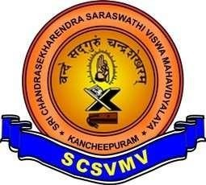
SRI CHANDRASEKHARENDRA SARASWATHI VISWA MAHAVIDYALAYA
(UNIVERSITY ESTABLISHED UNDER SECTION 3 OF UGC ACT 1956)
ENATHUR, KANCHIPURAM – 631 561

DEPARTMENT OF COMPUTER SCIENCE & ENGINEERING

Name :_ E. Sri Thanmai
Reg. No : 11239A026
Class : III B.E. (CSE) S1 Section

Course Code: BCSF186P80
Course Name: OPEN CV LAB
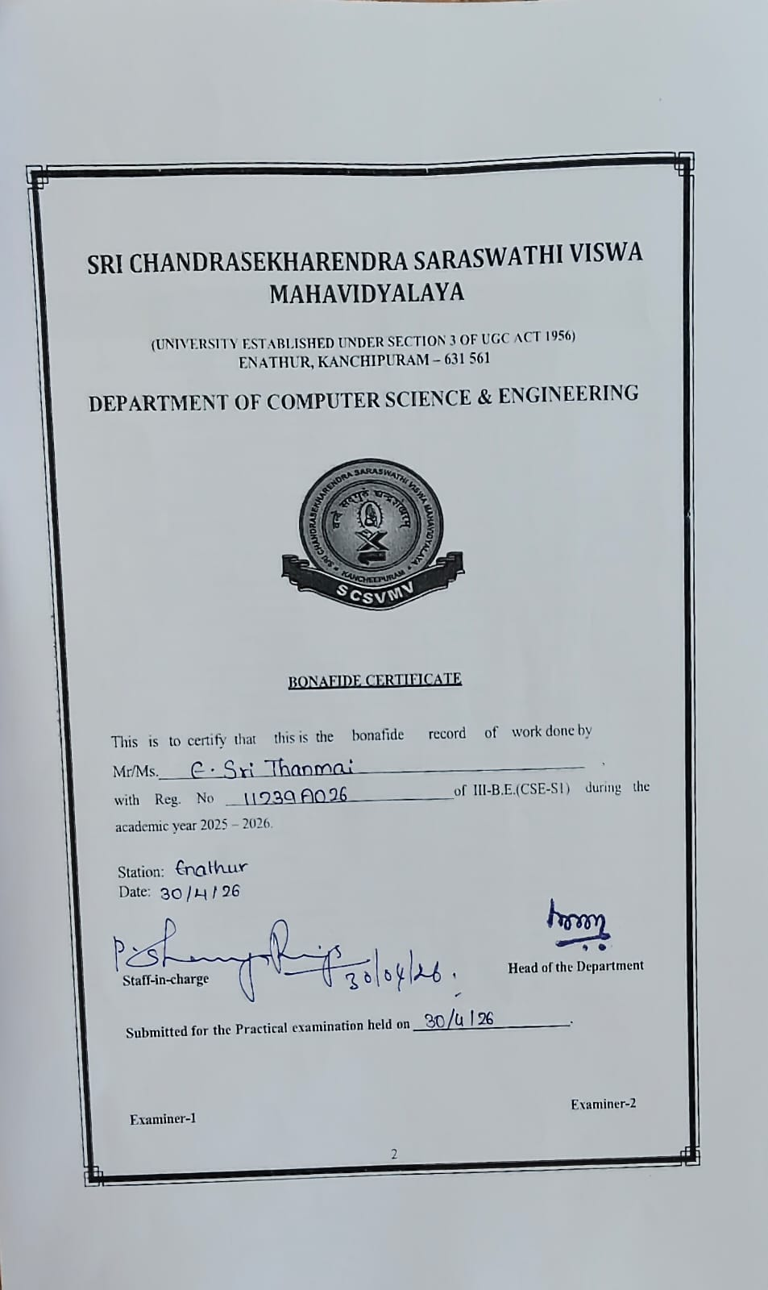

INDEX

SL. NO | PROGRAM NAME | DATE | PAGE NO | SIGNATURE
1 | Read and Display Image | 27.01.2026 | 4
2 | Display Properties of Image | 27.01.2026 | 6
3 | Convert Image to Grayscale | 27.01.2026 | 8
4 | Convert Image to HSV | 02.02.2026 | 10
5 | Add Text on Image | 02.02.2026 | 12
6 | Draw Different Shapes | 02.02.2026 | 14
7 | Read and Display Various Image Formats | 09.02.2026 | 16
8 | Convert Image to Various Formats | 09.02.2026 | 18
9 | Rotate Image at Various Angles | 09.02.2026 | 20
10 | Crop an Image | 09.02.2026 | 22
11 | Image Flipping | 17.02.2026 | 24
12 | Image Smoothing and Blurring | 17.02.2026 | 26
13 | Histogram Analysis | 17.02.2026 | 28
14 | Edge Detection | 02.03.2026 | 30
15 | Binary Image Processing | 02.03.2026 | 32
16 | Erosion | 02.03.2026 | 34
17 | Dilation | 02.03.2026 | 36
18 | Opening | 17.03.2026 | 38
19 | Closing | 17.03.2026 | 40
20 | Morphological Gradient | 17.03.2026 | 42
21 | Top Hat Transformation | 17.03.2026 | 44
22 | Black Hat Transformation | 30.03.2026 | 46
23 | Structuring Elements | 30.03.2026 | 48
24 | Basic Text Recognition from Image (OCR using Tesseract) | 30.03.2026 | 50

Ex. No.: 01 READ AND DISPLAY IMAGE

Date: 27.01.2026

AIM:

To read an image from disk and display it in a window using OpenCV.

PROCEDURE:

- Import the OpenCV library using import cv2.
- Use cv2.imread('image.jpg') to load the image from the disk into memory.
- Check that the image was loaded successfully (it should not be None).
- Use cv2.imshow('Image', img) to open a display window and show the image.
- Call cv2.waitKey(0) to pause execution and keep the window open until a key is pressed.
- Call cv2.destroyAllWindows() to close all open display windows.

CODE:

import cv2
img = cv2.imread('image.jpg')
if img is None:
print("Error: Image not found.")
else:
cv2.imshow('Image', img)
cv2.waitKey(0)
cv2.destroyAllWindows()

RESULT:
The image was successfully read from disk and displayed in an OpenCV window.

Output :

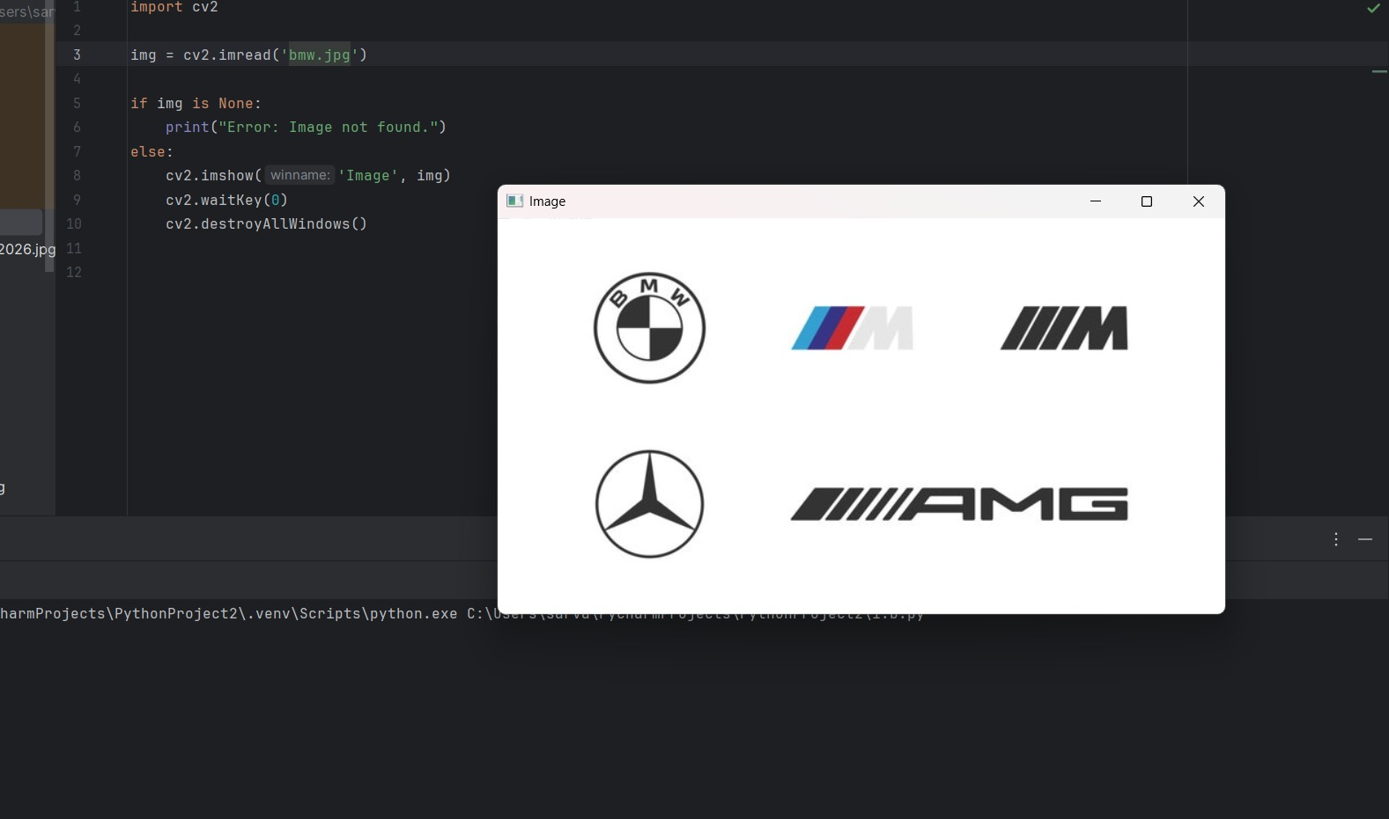

Ex. No.: 02 DISPLAY PROPERTIES OF IMAGE

Date: 27.01.2026

AIM:

To read an image and display its properties such as shape, size, and data type.

PROCEDURE:

- Import the OpenCV library using import cv2.
- Load the image using cv2.imread('image.jpg').
- Print img.shape to get the image dimensions (height, width, number of channels).
- Print img.size to get the total number of pixel elements.
- Print img.dtype to get the data type of the pixel values.
- Observe the output in the console.

CODE:

import cv2
img = cv2.imread('image.jpg')
print("Shape (Height x Width x Channels):", img.shape)
print("Total Size (pixels):", img.size)
print("Data Type:", img.dtype)

RESULT:

The shape, size, and data type of the image were successfully retrieved and displayed.

Output :
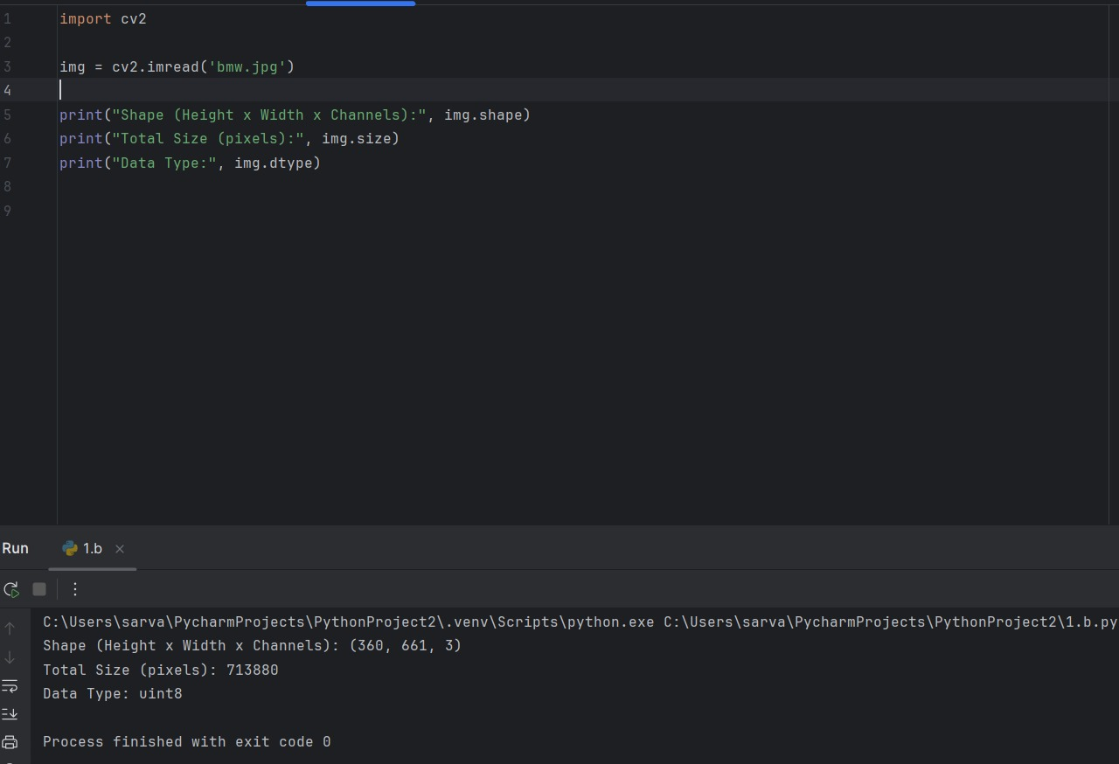

Ex. No.: 03 CONVERT IMAGE TO GRAYSCALE

Date: 27.01.2026

AIM:

To convert a color (BGR) image to a grayscale image using OpenCV.

PROCEDURE:

- Import the OpenCV library using import cv2.
- Load the color image using cv2.imread('image.jpg').
- Use cv2.cvtColor(img, cv2.COLOR_BGR2GRAY) to convert the image to grayscale.
- Display the grayscale image using cv2.imshow('Grayscale', gray).
- Call cv2.waitKey(0) to keep the window open.
- Close all windows using cv2.destroyAllWindows().

CODE:

import cv2

img = cv2.imread('image.jpg')
gray = cv2.cvtColor(img, cv2.COLOR_BGR2GRAY)

cv2.imshow('Grayscale Image', gray)
cv2.waitKey(0)
cv2.destroyAllWindows()

RESULT:

The color image was successfully converted to grayscale and displayed.

Output :

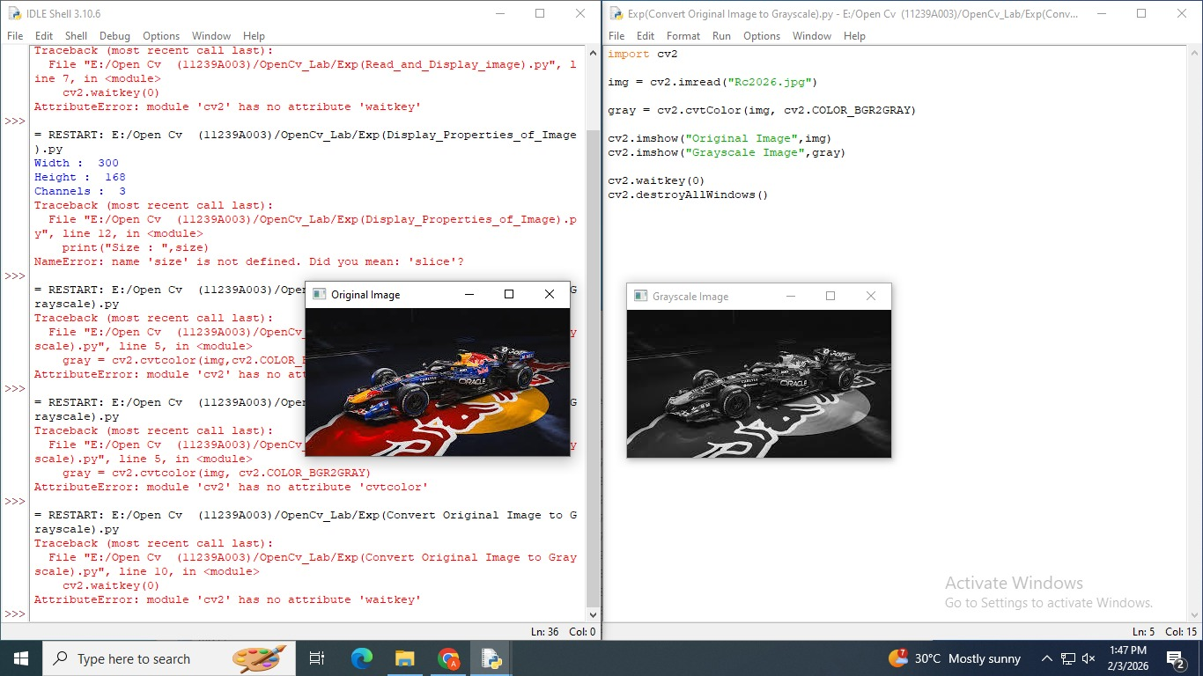
Ex. No.: 04 CONVERT IMAGE TO HSV

Date: 02.02.2026

AIM:

To convert a color image from BGR to HSV (Hue, Saturation, Value) color space using OpenCV.

PROCEDURE:
- Import the OpenCV library using import cv2.
- Load the color image using cv2.imread('image.jpg').
- Use cv2.cvtColor(img, cv2.COLOR_BGR2HSV) to convert the image to HSV color space.
- Display the HSV image using cv2.imshow('HSV Image', hsv).
- Call cv2.waitKey(0) to keep the window open.
- Close all windows using cv2.destroyAllWindows().

CODE:

import cv2

img = cv2.imread('image.jpg')
hsv = cv2.cvtColor(img, cv2.COLOR_BGR2HSV)

cv2.imshow('HSV Image', hsv)
cv2.waitKey(0)
cv2.destroyAllWindows()

RESULT:

The image was successfully converted from BGR to HSV color space and displayed.

Output :

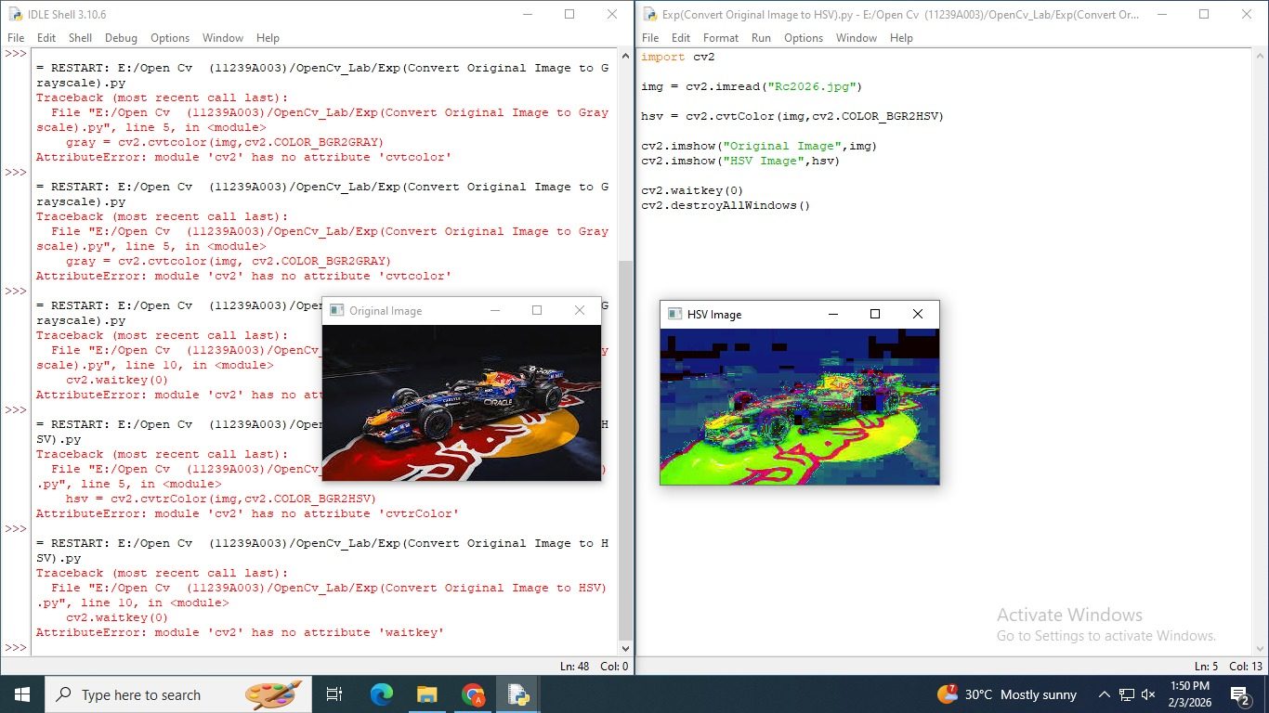
Ex. No.: 05 ADD TEXT ON IMAGE

Date: 02.02.2026

AIM:

To overlay text on an image using OpenCV's cv2.putText() function.

PROCEDURE:

- Import the OpenCV library using import cv2.
- Load the image using cv2.imread('image.jpg').
- Select a font style using cv2.FONT_HERSHEY_SIMPLEX.
- Use cv2.putText() with parameters: image, text string, position (x, y), font, font scale, color (B, G, R), and thickness.
- Display the result using cv2.imshow().
- Wait for a key press and close all windows.

CODE:

import cv2

img = cv2.imread('image.jpg')
font = cv2.FONT_HERSHEY_SIMPLEX

cv2.putText(img, 'OpenCV Lab', (50, 50), font, 1.2, (0, 255, 0), 2)

cv2.imshow('Image with Text', img)
cv2.waitKey(0)
cv2.destroyAllWindows()

RESULT:

Text was successfully overlaid on the image at the specified position using cv2.putText().

Output :

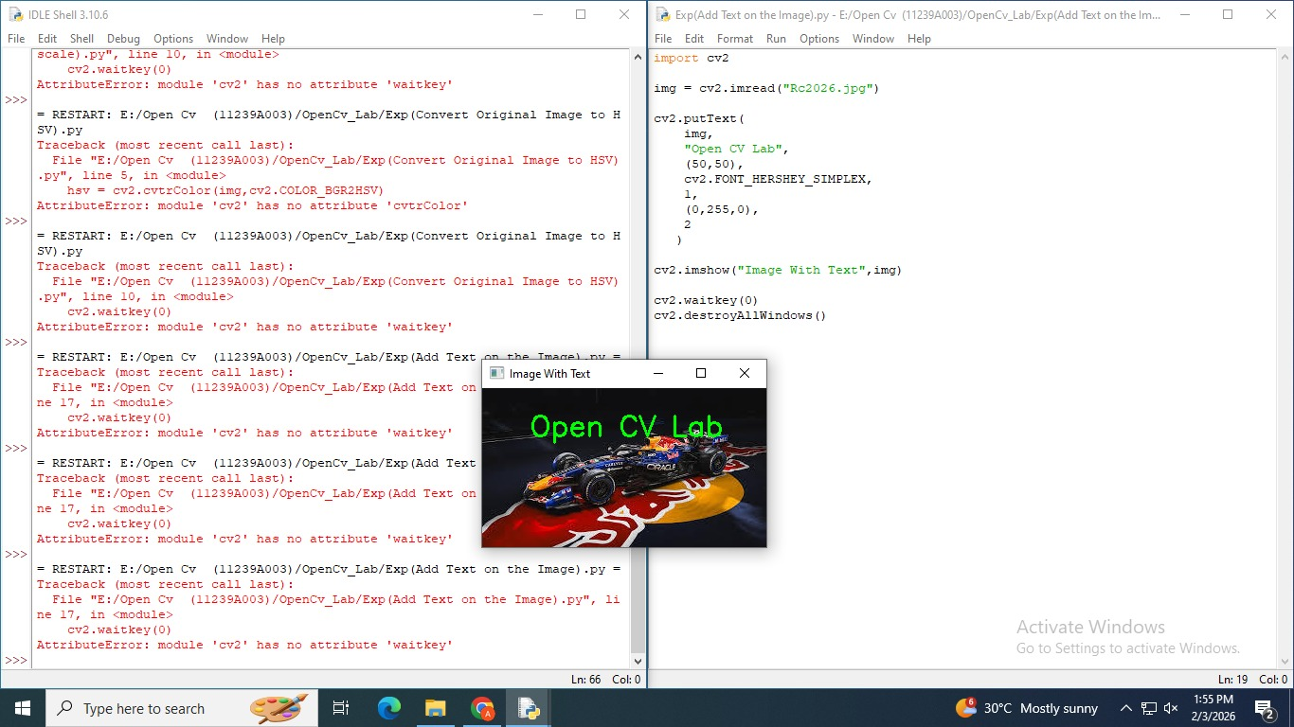
Ex. No.: 06 DRAW DIFFERENT SHAPES

Date: 02.02.2026

AIM:
To draw basic shapes such as lines, circles, rectangles, and ellipses on a blank image using OpenCV.
PROCEDURE:
- Import cv2 and numpy.
- Create a blank black image using np.zeros((400, 400, 3), dtype=np.uint8).
- Draw a line using cv2.line() by specifying start and end points.
- Draw a circle using cv2.circle() by specifying center, radius, and color.
- Draw a rectangle using cv2.rectangle() with top-left and bottom-right corners.
- Draw an ellipse using cv2.ellipse() and display the final image.
CODE:
import cv2
import numpy as np

img = np.zeros((400, 400, 3), dtype=np.uint8)

cv2.line(img, (0, 0), (400, 400), (0, 255, 0), 2)
cv2.circle(img, (200, 200), 80, (0, 0, 255), 3)
cv2.rectangle(img, (50, 50), (180, 150), (255, 0, 0), 2)
cv2.ellipse(img, (300, 100), (60, 30), 0, 0, 360, (255, 255, 0), 2)

cv2.imshow('Shapes', img)
cv2.waitKey(0)
cv2.destroyAllWindows()

RESULT:
A line, circle, rectangle, and ellipse were successfully drawn on a blank image.

Output :

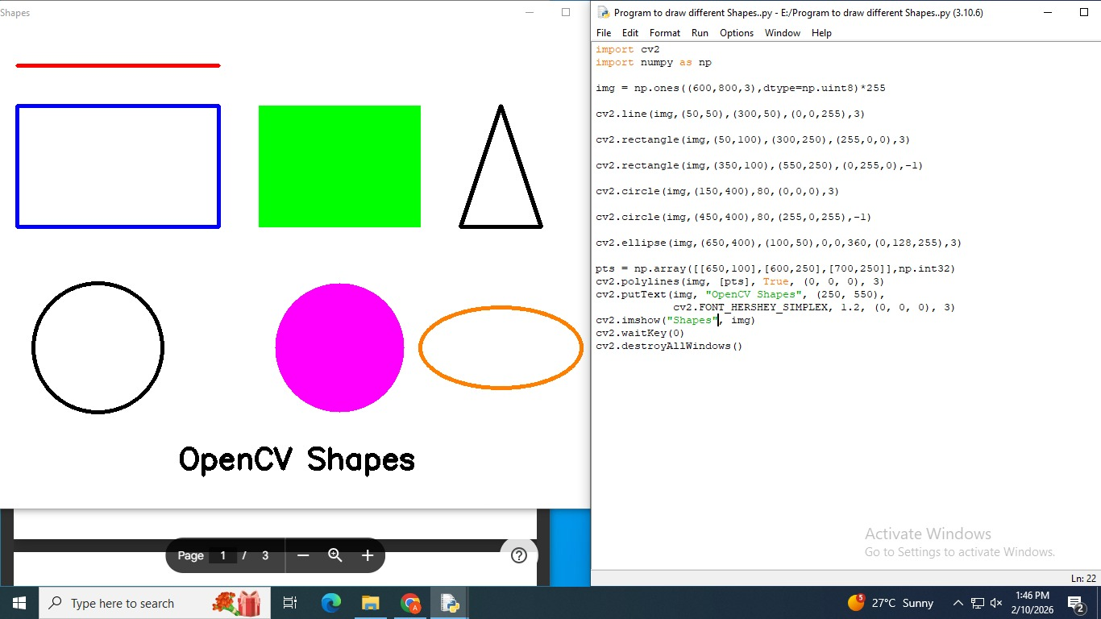
Ex. No.: 07 READ AND DISPLAY VARIOUS IMAGE FORMATS

Date: 09.02.2026

AIM:
To read and display image files in different formats (JPG, PNG, BMP, TIFF) using OpenCV.
PROCEDURE:
- Import the OpenCV library using import cv2.
- Create a list of image filenames with different extensions: .jpg, .png, .bmp, .tiff.
- Use a loop to iterate through the list.
- For each file, use cv2.imread() to load the image.
- Check if the image was loaded successfully before displaying.
- Display each image using cv2.imshow() and wait for a key press; close all windows after the loop.
CODE:
import cv2

formats = ['image.jpg', 'image.png', 'image.bmp', 'image.tiff']

for filename in formats:
img = cv2.imread(filename)
if img is not None:
cv2.imshow(f'Format: {filename}', img)
cv2.waitKey(0)
else:
print(f"Could not read: {filename}")

cv2.destroyAllWindows()

RESULT:
Images in JPG, PNG, BMP, and TIFF formats were successfully read and displayed using OpenCV.

Output :

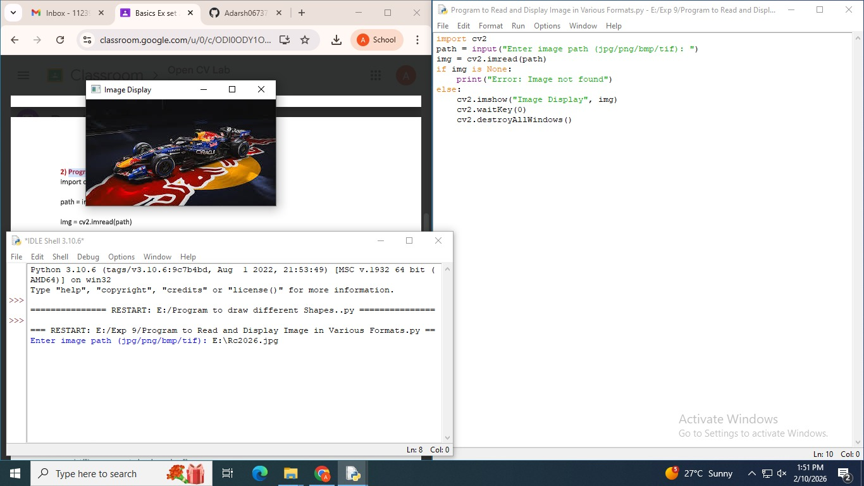
Ex. No.: 08 CONVERT IMAGE TO VARIOUS FORMATS

Date: 09.02.2026

AIM:
To read an image and save (convert) it into multiple file formats including JPG, PNG, BMP, and TIFF.
PROCEDURE:
- Import the OpenCV library using import cv2.
- Load the source image using cv2.imread('image.jpg').
- Use cv2.imwrite('output.png', img) to save the image in PNG format.
- Use cv2.imwrite('output.bmp', img) to save in BMP format.
- Use cv2.imwrite('output.tiff', img) to save in TIFF format.
- Print a confirmation message after each save to verify success.
CODE:
import cv2

img = cv2.imread('image.jpg')

cv2.imwrite('output.png', img)
print("Saved as PNG")

cv2.imwrite('output.bmp', img)
print("Saved as BMP")

cv2.imwrite('output.tiff', img)
print("Saved as TIFF")

cv2.imwrite('output_copy.jpg', img)
print("Saved as JPG")

print("All formats saved successfully.")

RESULT:
The image was successfully converted and saved in JPG, PNG, BMP, and TIFF formats.

Output :

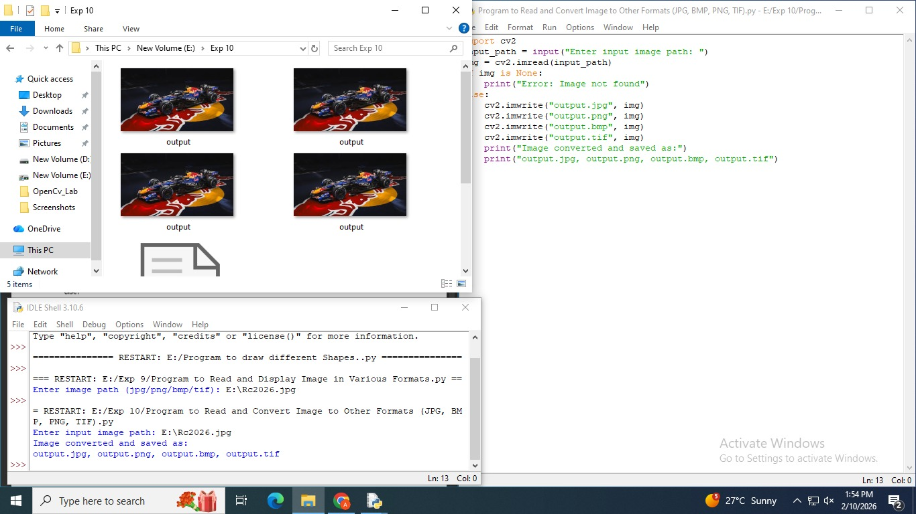
Ex. No.: 09 ROTATE IMAGE AT VARIOUS ANGLES

Date: 09.02.2026

AIM:
To rotate an image at multiple angles (45°, 90°, 180°) using OpenCV's affine transformation.
PROCEDURE:
- Import the OpenCV library using import cv2.
- Load the image and get its dimensions using img.shape[:2].
- Compute the center of the image for rotation.
- Use cv2.getRotationMatrix2D(center, angle, scale) to generate the rotation matrix.
- Apply the rotation using cv2.warpAffine(img, M, (width, height)).
- Repeat for angles 45°, 90°, and 180°, displaying each result.
CODE:
import cv2

img = cv2.imread('image.jpg')
h, w = img.shape[:2]
center = (w // 2, h // 2)

for angle in [45, 90, 180]:
M = cv2.getRotationMatrix2D(center, angle, 1.0)
rotated = cv2.warpAffine(img, M, (w, h))
cv2.imshow(f'Rotated {angle} degrees', rotated)
cv2.waitKey(0)

cv2.destroyAllWindows()

RESULT:
The image was successfully rotated at 45°, 90°, and 180° and displayed.

Output :

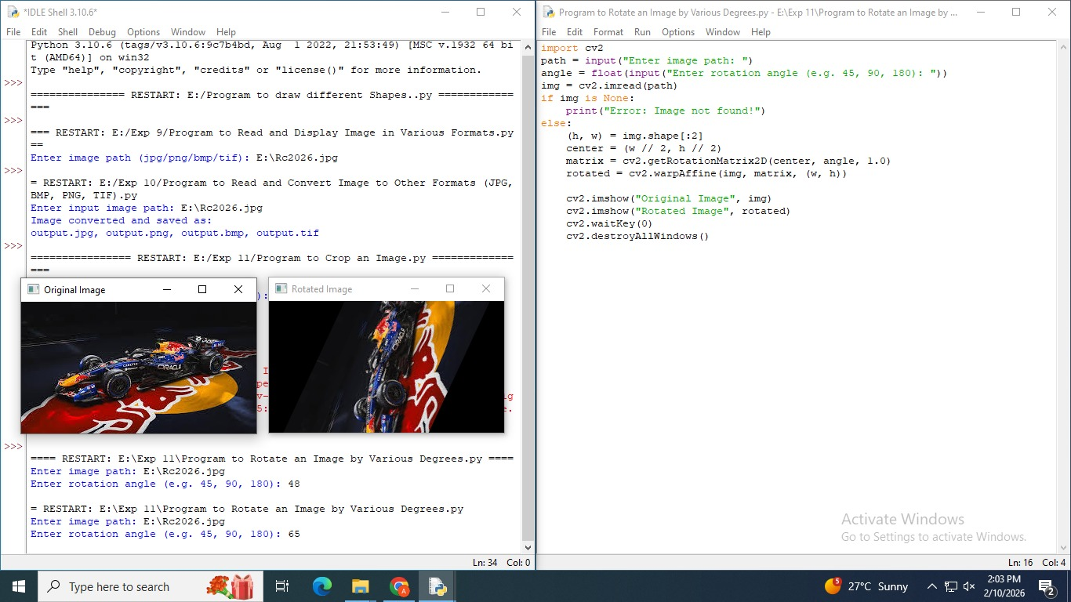
Ex. No.: 10 CROP AN IMAGE

Date: 09.02.2026

AIM:
To crop a specific region of interest (ROI) from an image using NumPy array slicing.
PROCEDURE:
- Import the OpenCV library using import cv2.
- Load the image using cv2.imread('image.jpg').
- Identify the desired region by specifying pixel coordinates: start and end values for rows (y) and columns (x).
- Crop the region using NumPy slicing syntax: cropped = img[y1:y2, x1:x2].
- Display the cropped region using cv2.imshow().
- Wait for a key press and close all windows.
CODE:
import cv2

img = cv2.imread('image.jpg')

# Crop region: rows 50 to 200, columns 100 to 300
cropped = img[50:200, 100:300]

cv2.imshow('Original Image', img)
cv2.imshow('Cropped Region', cropped)
cv2.waitKey(0)
cv2.destroyAllWindows()

RESULT:
A specific region of interest was successfully cropped from the image and displayed.

Output :

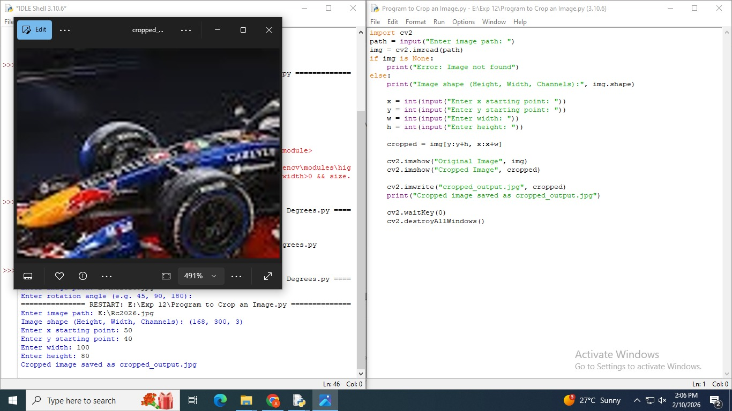

Ex. No.: 11 IMAGE FLIPPING

Date: 17.02.2026

AIM:
To flip an image horizontally, vertically, and in both directions using OpenCV.
PROCEDURE:
- Import the OpenCV library using import cv2.
- Load the image using cv2.imread('image.jpg').
- Use cv2.flip(img, 1) for horizontal flip (left-right).
- Use cv2.flip(img, 0) for vertical flip (top-bottom).
- Use cv2.flip(img, -1) to flip in both directions simultaneously.
- Display the original and all three flipped images.
CODE:
import cv2

img = cv2.imread('image.jpg')

h_flip = cv2.flip(img, 1) # Horizontal
v_flip = cv2.flip(img, 0) # Vertical
both = cv2.flip(img, -1) # Both

cv2.imshow('Original', img)
cv2.imshow('Horizontal Flip', h_flip)
cv2.imshow('Vertical Flip', v_flip)
cv2.imshow('Both Directions', both)
cv2.waitKey(0)
cv2.destroyAllWindows()

RESULT:
The image was successfully flipped horizontally, vertically, and in both directions.

Output :

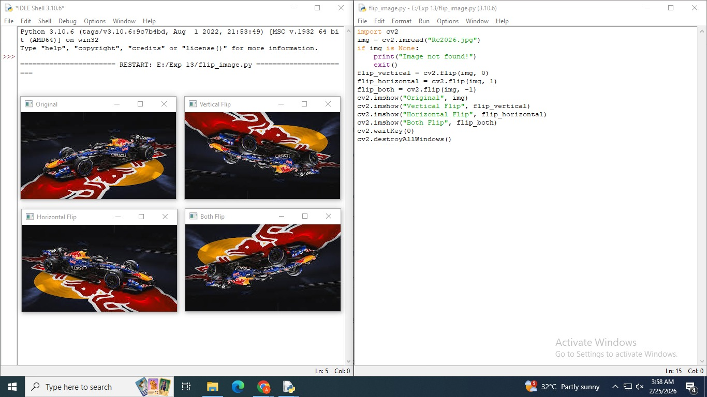
Ex. No.: 12 IMAGE SMOOTHING AND BLURRING

Date: 17.02.2026

AIM:
To apply different blurring techniques — Average, Gaussian, and Median blur — to an image using OpenCV.
PROCEDURE:
- Import the OpenCV library using import cv2.
- Load the image using cv2.imread('image.jpg').
- Apply Average Blur using cv2.blur(img, (5, 5)) with a 5x5 kernel.
- Apply Gaussian Blur using cv2.GaussianBlur(img, (5, 5), 0).
- Apply Median Blur using cv2.medianBlur(img, 5).
- Display all results side by side for comparison.
CODE:
import cv2

img = cv2.imread('image.jpg')

avg_blur = cv2.blur(img, (5, 5))
gauss_blur = cv2.GaussianBlur(img, (5, 5), 0)
med_blur = cv2.medianBlur(img, 5)

cv2.imshow('Original', img)
cv2.imshow('Average Blur', avg_blur)
cv2.imshow('Gaussian Blur', gauss_blur)
cv2.imshow('Median Blur', med_blur)
cv2.waitKey(0)
cv2.destroyAllWindows()

RESULT:
Average, Gaussian, and Median blurring techniques were applied successfully to the image.

Output :

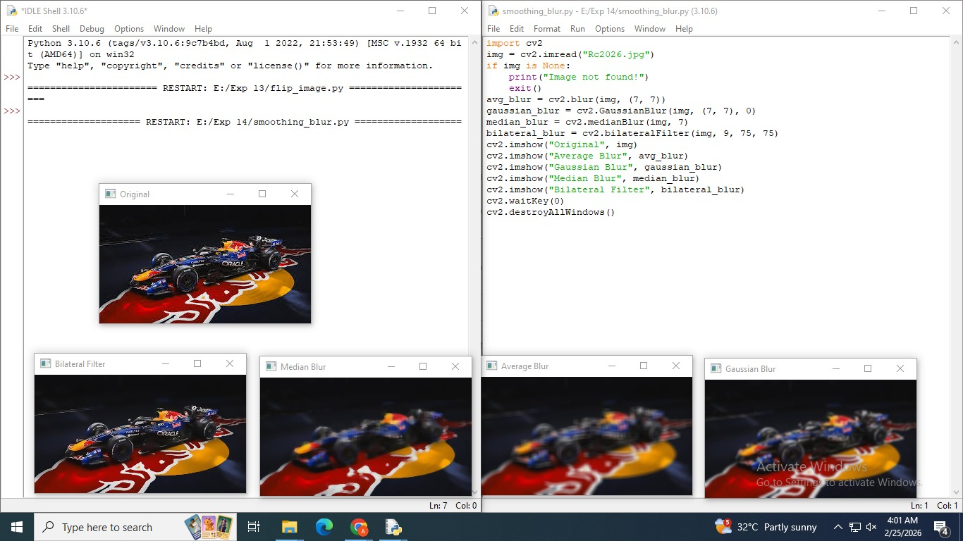
Ex. No.: 13 HISTOGRAM ANALYSIS

Date: 17.02.2026

AIM:
To compute and plot the pixel intensity histogram of a grayscale image using OpenCV and Matplotlib.
PROCEDURE:
- Import cv2 and matplotlib.pyplot as plt.
- Load the image and convert it to grayscale using cv2.cvtColor().
- Compute the histogram using cv2.calcHist([gray], [0], None, [256], [0, 256]).
- Plot the histogram using plt.plot(hist).
- Add labels and title to the plot for clarity.
- Call plt.show() to display the histogram graph.
CODE:
import cv2
import matplotlib.pyplot as plt

img = cv2.imread('image.jpg')
gray = cv2.cvtColor(img, cv2.COLOR_BGR2GRAY)

hist = cv2.calcHist([gray], [0], None, [256], [0, 256])

plt.figure()
plt.plot(hist, color='black')
plt.title('Grayscale Histogram')
plt.xlabel('Pixel Intensity (0-255)')
plt.ylabel('Frequency')
plt.xlim([0, 256])
plt.show()

RESULT:
The histogram of the grayscale image was computed and displayed, showing the distribution of pixel intensities.

Output :

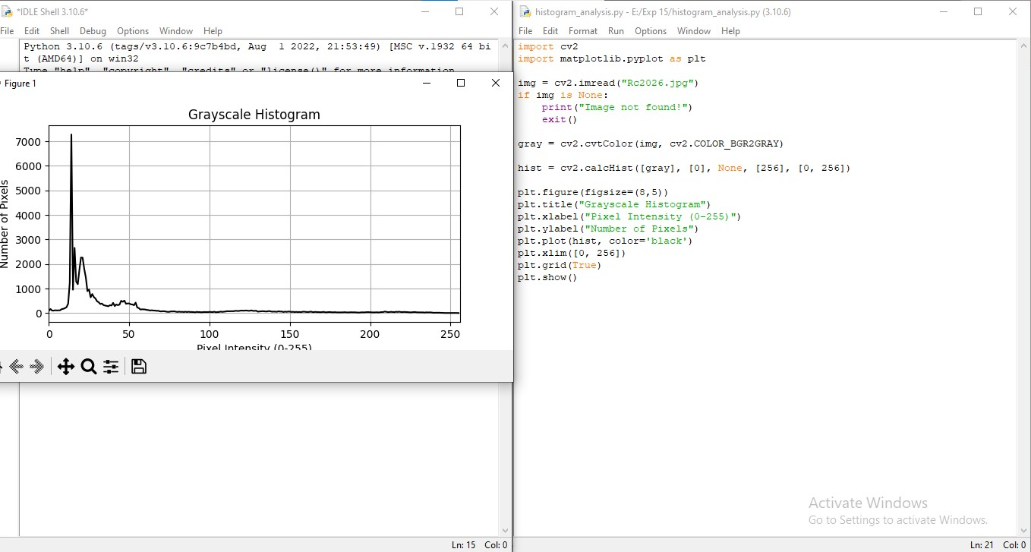
Ex. No.: 14 EDGE DETECTION

Date: 02.03.2026

AIM:
To detect edges in an image using the Canny edge detection algorithm.
PROCEDURE:
- Import the OpenCV library using import cv2.
- Load the image and convert it to grayscale using cv2.cvtColor().
- Apply cv2.Canny(gray, threshold1, threshold2) with lower threshold 100 and upper threshold 200.
- The Canny function automatically applies Gaussian smoothing, gradient computation, and hysteresis thresholding.
- Display the resulting edge-detected image using cv2.imshow().
- Wait for a key press and close all windows.
CODE:
import cv2

img = cv2.imread('image.jpg')
gray = cv2.cvtColor(img, cv2.COLOR_BGR2GRAY)

edges = cv2.Canny(gray, 100, 200)

cv2.imshow('Original', img)
cv2.imshow('Edge Detection (Canny)', edges)
cv2.waitKey(0)
cv2.destroyAllWindows()

RESULT:
Edges in the image were successfully detected using the Canny edge detector and displayed.

Output :

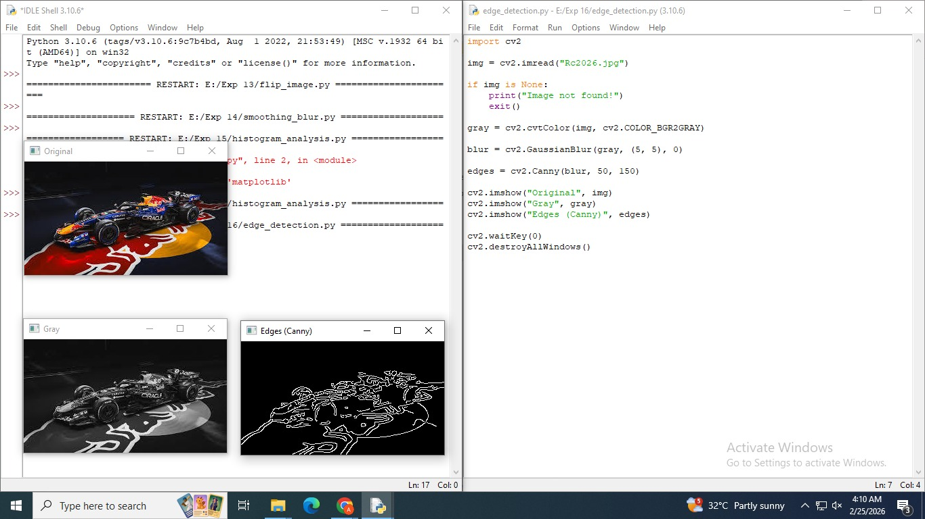

Ex. No.: 15 BINARY IMAGE PROCESSING

Date: 02.03.2026

AIM:
To apply binary thresholding and demonstrate erosion, dilation, opening, and closing on a grayscale image.
PROCEDURE:
- Import cv2 and numpy.
- Load the image in grayscale mode using cv2.imread('image.jpg', 0).
- Apply binary thresholding using cv2.threshold(img, 127, 255, cv2.THRESH_BINARY).
- Create a 5x5 kernel using np.ones((5, 5), np.uint8).
- Apply erosion using cv2.erode(), dilation using cv2.dilate(), opening and closing using cv2.morphologyEx().
- Display all results for comparison.
CODE:
import cv2
import numpy as np

img = cv2.imread('image.jpg', 0)
_, binary = cv2.threshold(img, 127, 255, cv2.THRESH_BINARY)

kernel = np.ones((5, 5), np.uint8)

eroded = cv2.erode(binary, kernel, iterations=1)
dilated = cv2.dilate(binary, kernel, iterations=1)
opened = cv2.morphologyEx(binary, cv2.MORPH_OPEN, kernel)
closed = cv2.morphologyEx(binary, cv2.MORPH_CLOSE, kernel)

cv2.imshow('Binary', binary)
cv2.imshow('Eroded', eroded)
cv2.imshow('Dilated', dilated)
cv2.imshow('Opened', opened)
cv2.imshow('Closed', closed)
cv2.waitKey(0)
cv2.destroyAllWindows()

RESULT:
Binary thresholding, erosion, dilation, opening, and closing were all applied and demonstrated successfully.

Output :

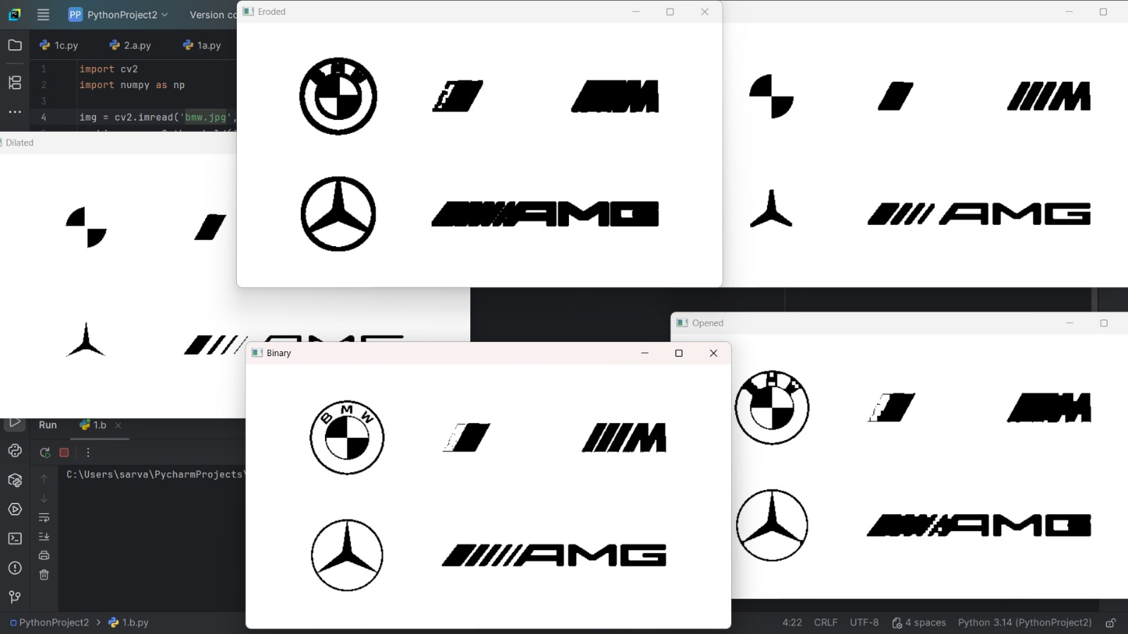
Ex. No.: 16 EROSION

Date: 02.03.2026
AIM:

To apply the erosion morphological operation to a binary image to shrink foreground objects.

PROCEDURE:

- Import cv2 and numpy.
- Load the image in grayscale mode using cv2.imread('image.jpg', 0).
- Convert to binary using cv2.threshold().
- Define a 5x5 kernel using np.ones((5, 5), np.uint8).
- Apply erosion using cv2.erode(binary, kernel, iterations=1).
- Display the original binary image and the eroded result.
CODE:

import cv2
import numpy as np

img = cv2.imread('image.jpg', 0)
_, binary = cv2.threshold(img, 127, 255, cv2.THRESH_BINARY)

kernel = np.ones((5, 5), np.uint8)
eroded = cv2.erode(binary, kernel, iterations=1)

cv2.imshow('Original Binary', binary)
cv2.imshow('Eroded', eroded)
cv2.waitKey(0)
cv2.destroyAllWindows()

RESULT:

Erosion was applied successfully, shrinking foreground objects in the binary image.

Output :

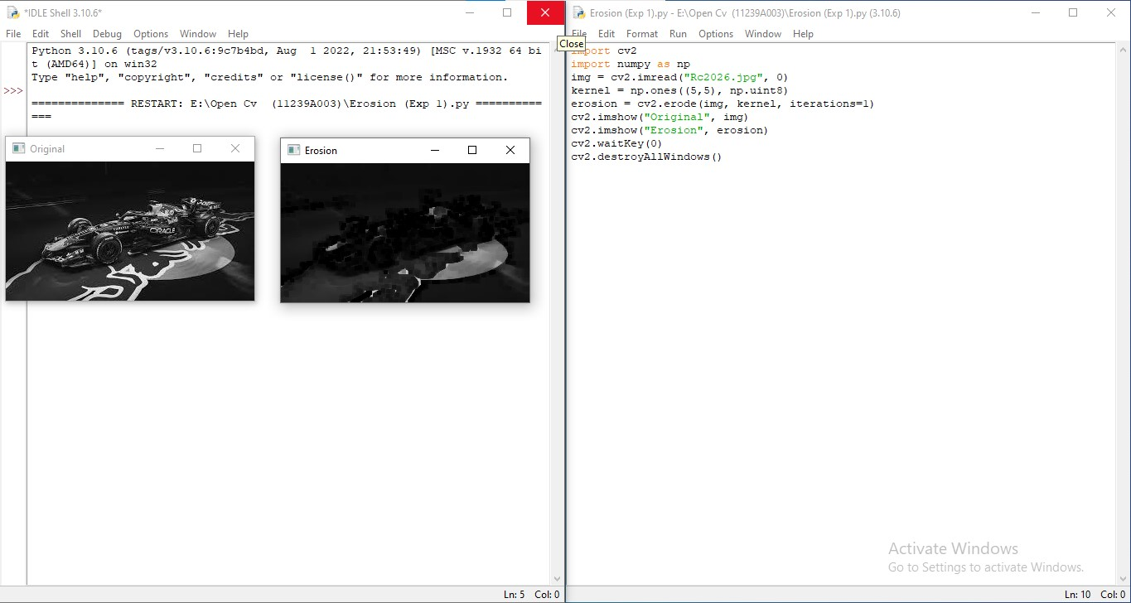
Ex. No.: 17 DILATION

Date: 02.03.2026

AIM:

To apply the dilation morphological operation to a binary image to expand foreground objects.

PROCEDURE:

- Import cv2 and numpy.
- Load the image in grayscale mode using cv2.imread('image.jpg', 0).
- Convert to binary using cv2.threshold().
- Define a 5x5 kernel using np.ones((5, 5), np.uint8).
- Apply dilation using cv2.dilate(binary, kernel, iterations=1).
- Display the original binary image and the dilated result.

CODE:

import cv2
import numpy as np

img = cv2.imread('image.jpg', 0)
_, binary = cv2.threshold(img, 127, 255, cv2.THRESH_BINARY)

kernel = np.ones((5, 5), np.uint8)
dilated = cv2.dilate(binary, kernel, iterations=1)

cv2.imshow('Original Binary', binary)
cv2.imshow('Dilated', dilated)
cv2.waitKey(0)
cv2.destroyAllWindows()

RESULT:

Dilation was applied successfully, expanding foreground objects in the binary image.

Output :

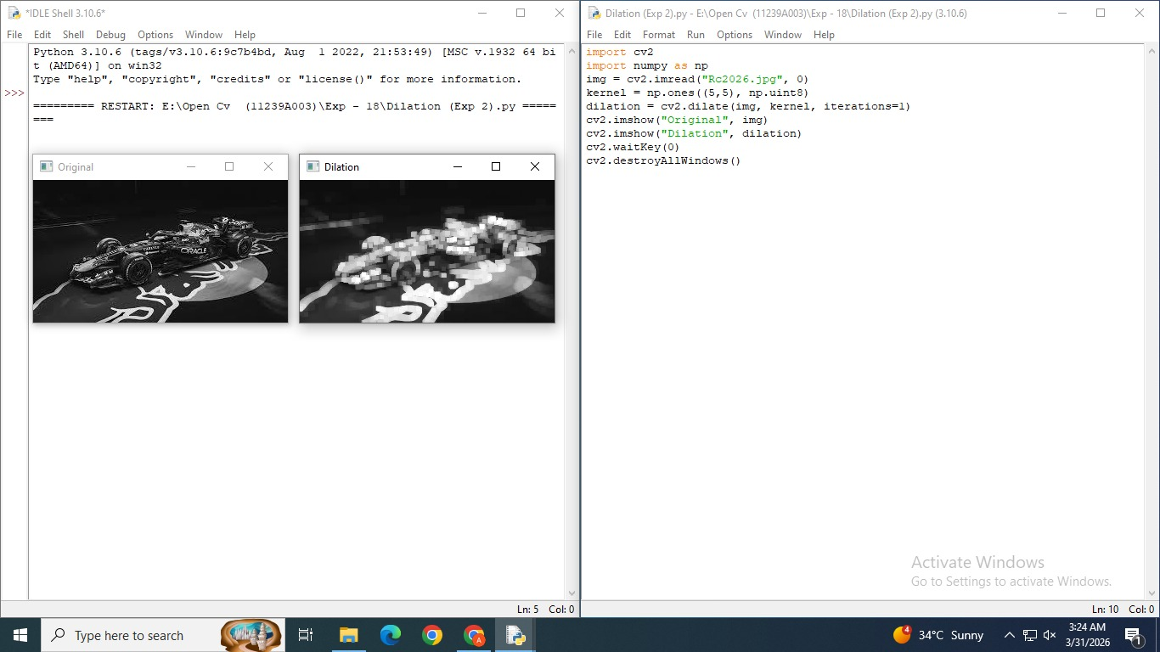
Ex. No.: 18 OPENING

Date: 17.03.2026

AIM:

To apply the morphological opening operation (erosion followed by dilation) to remove small noise from a binary image.

PROCEDURE:

- Import cv2 and numpy.
- Load the image in grayscale mode and convert it to binary using cv2.threshold().
- Define a 5x5 kernel using np.ones((5, 5), np.uint8).
- Apply morphological opening using cv2.morphologyEx(binary, cv2.MORPH_OPEN, kernel).
- Display both the original binary and the opened image.
- Observe the removal of small white noise regions.

CODE:

import cv2
import numpy as np

img = cv2.imread('image.jpg', 0)
_, binary = cv2.threshold(img, 127, 255, cv2.THRESH_BINARY)

kernel = np.ones((5, 5), np.uint8)
opened = cv2.morphologyEx(binary, cv2.MORPH_OPEN, kernel)

cv2.imshow('Original Binary', binary)
cv2.imshow('Opened', opened)
cv2.waitKey(0)
cv2.destroyAllWindows()

RESULT:

Morphological opening was applied, removing small noise from the binary image while preserving larger objects.

Output :

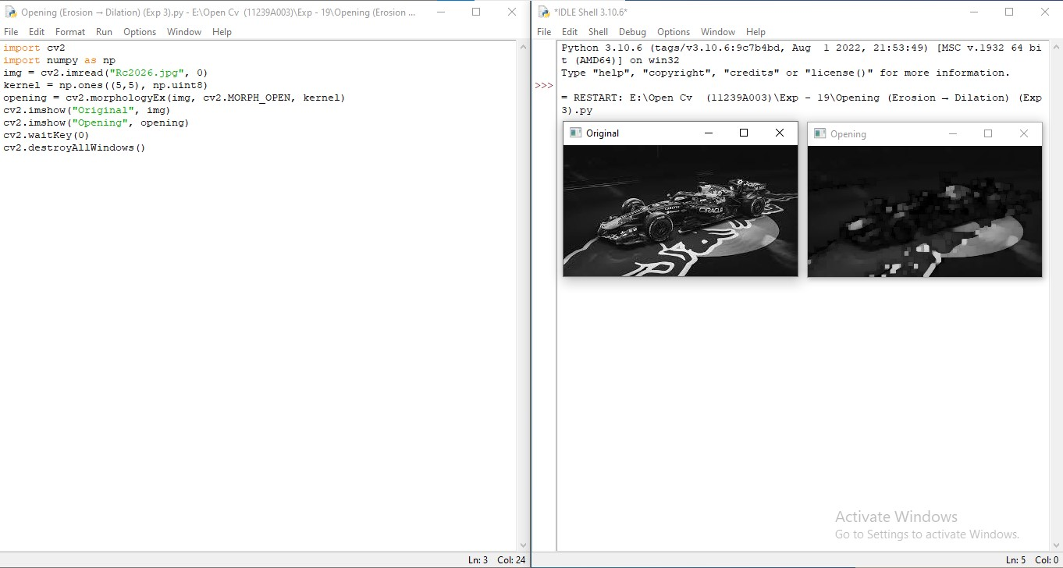

Ex. No.: 19 CLOSING

Date: 17.03.2026

AIM:

To apply the morphological closing operation (dilation followed by erosion) to fill small holes in foreground objects.

PROCEDURE:

- Import cv2 and numpy.
- Load the image in grayscale mode and apply binary thresholding.
- Define a 5x5 kernel using np.ones((5, 5), np.uint8).
- Apply morphological closing using cv2.morphologyEx(binary, cv2.MORPH_CLOSE, kernel).
- Display the original binary and the closed image.
- Observe how small holes inside white regions are filled.

CODE:

import cv2
import numpy as np

img = cv2.imread('image.jpg', 0)
_, binary = cv2.threshold(img, 127, 255, cv2.THRESH_BINARY)

kernel = np.ones((5, 5), np.uint8)
closed = cv2.morphologyEx(binary, cv2.MORPH_CLOSE, kernel)

cv2.imshow('Original Binary', binary)
cv2.imshow('Closed', closed)
cv2.waitKey(0)
cv2.destroyAllWindows()

RESULT:

Morphological closing was applied successfully, filling small holes within foreground objects.

Output :

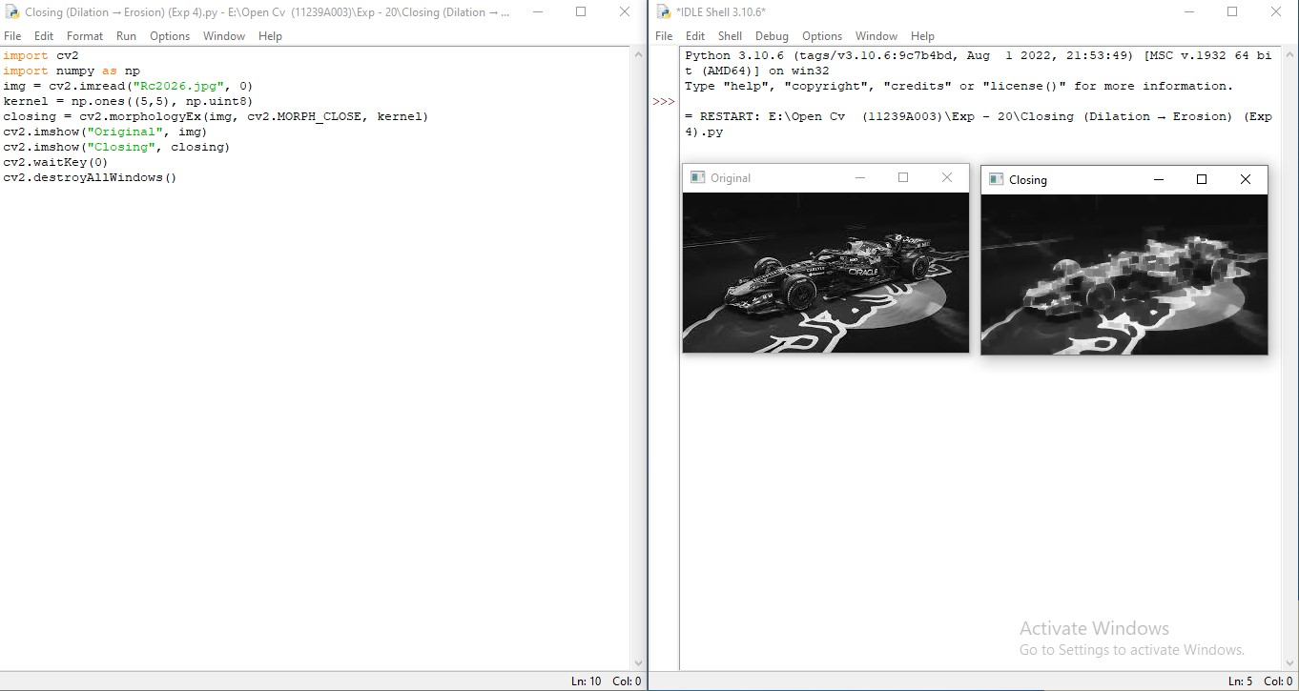
Ex. No.: 20 MORPHOLOGICAL GRADIENT

Date: 17.03.2026

AIM:

To compute the morphological gradient of a binary image to highlight object boundaries.

PROCEDURE:

- Import cv2 and numpy.
- Load the image in grayscale mode and apply binary thresholding.
- Define a 5x5 kernel using np.ones((5, 5), np.uint8).
- Apply the morphological gradient using cv2.morphologyEx(binary, cv2.MORPH_GRADIENT, kernel).
- The gradient is computed as the difference between dilation and erosion.
- Display the result to observe highlighted edges/boundaries.

CODE:

import cv2
import numpy as np

img = cv2.imread('image.jpg', 0)
_, binary = cv2.threshold(img, 127, 255, cv2.THRESH_BINARY)

kernel = np.ones((5, 5), np.uint8)
gradient = cv2.morphologyEx(binary, cv2.MORPH_GRADIENT, kernel)

cv2.imshow('Original Binary', binary)
cv2.imshow('Morphological Gradient', gradient)
cv2.waitKey(0)
cv2.destroyAllWindows()

RESULT:

The morphological gradient was computed successfully, highlighting the boundaries of objects in the image.

Output :

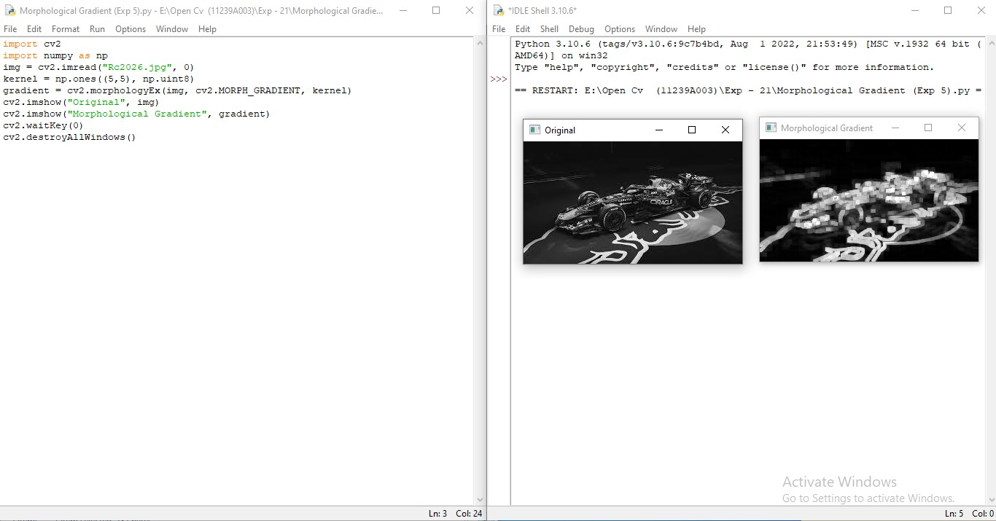
Ex. No.: 21 TOP HAT TRANSFORMATION

Date: 17.03.2026

AIM:

To apply the Top Hat transformation to reveal bright features that are smaller than the structuring element.

PROCEDURE:

- Import cv2 and numpy.
- Load the image in grayscale mode using cv2.imread('image.jpg', 0).
- Define a 9x9 rectangular kernel using np.ones((9, 9), np.uint8).
- Apply the Top Hat transformation using cv2.morphologyEx(img, cv2.MORPH_TOPHAT, kernel).
- Top Hat = Original Image minus Opened Image, revealing small bright regions.
- Display the original and the Top Hat result.

CODE:

import cv2
import numpy as np

img = cv2.imread('image.jpg', 0)
kernel = np.ones((9, 9), np.uint8)
tophat = cv2.morphologyEx(img, cv2.MORPH_TOPHAT, kernel)

cv2.imshow('Original', img)
cv2.imshow('Top Hat', tophat)
cv2.waitKey(0)
cv2.destroyAllWindows()

RESULT:

The Top Hat transformation was applied successfully, highlighting small bright regions on a dark background.

Output :

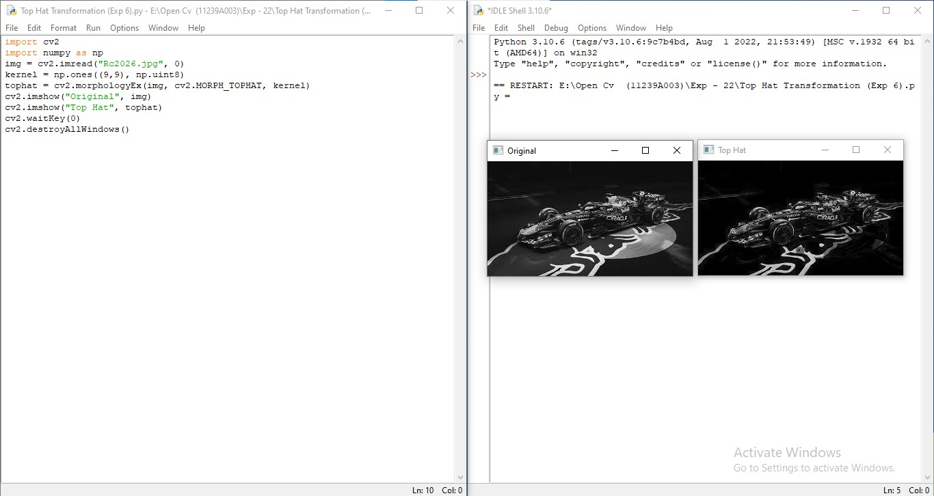
Ex. No.: 22 BLACK HAT TRANSFORMATION

Date: 30.03.2026

AIM:

To apply the Black Hat transformation to reveal dark features that are smaller than the structuring element.

PROCEDURE:

- Import cv2 and numpy.
- Load the image in grayscale mode using cv2.imread('image.jpg', 0).
- Define a 9x9 rectangular kernel using np.ones((9, 9), np.uint8).
- Apply the Black Hat transformation using cv2.morphologyEx(img, cv2.MORPH_BLACKHAT, kernel).
- Black Hat = Closed Image minus Original Image, revealing small dark features.
- Display both the original and the Black Hat result.

CODE:

import cv2
import numpy as np

img = cv2.imread('image.jpg', 0)
kernel = np.ones((9, 9), np.uint8)
blackhat = cv2.morphologyEx(img, cv2.MORPH_BLACKHAT, kernel)

cv2.imshow('Original', img)
cv2.imshow('Black Hat', blackhat)
cv2.waitKey(0)
cv2.destroyAllWindows()

RESULT:

The Black Hat transformation was applied successfully, highlighting small dark regions on a bright background.

Output :

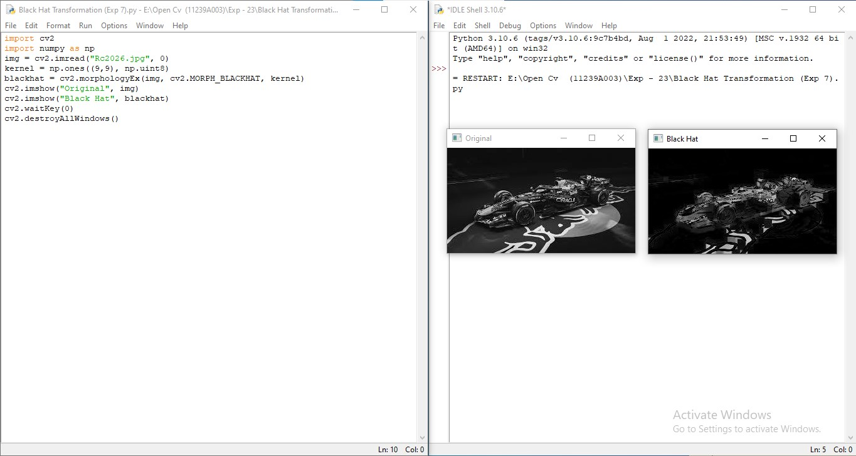
Ex. No.: 23 STRUCTURING ELEMENTS

Date: 30.03.2026

AIM:

To create and display different structuring elements: Rectangular, Elliptical, and Cross-shaped.

PROCEDURE:

- Import the OpenCV library using import cv2.
- Use cv2.getStructuringElement(cv2.MORPH_RECT, (5, 5)) to create a rectangular kernel.
- Use cv2.getStructuringElement(cv2.MORPH_ELLIPSE, (5, 5)) to create an elliptical kernel.
- Use cv2.getStructuringElement(cv2.MORPH_CROSS, (5, 5)) to create a cross-shaped kernel.
- Print each structuring element to the console to observe its shape.
- Note that these kernels can be used as parameters in morphological operations.

CODE:

import cv2

rect_kernel = cv2.getStructuringElement(cv2.MORPH_RECT, (5, 5))
ellipse_kernel = cv2.getStructuringElement(cv2.MORPH_ELLIPSE, (5, 5))
cross_kernel = cv2.getStructuringElement(cv2.MORPH_CROSS, (5, 5))

print("Rectangular Kernel (5x5):")
print(rect_kernel)

print("\nElliptical Kernel (5x5):")
print(ellipse_kernel)

print("\nCross-Shaped Kernel (5x5):")
print(cross_kernel)

RESULT:

Rectangular, elliptical, and cross-shaped structuring elements were successfully created and displayed.

Output :

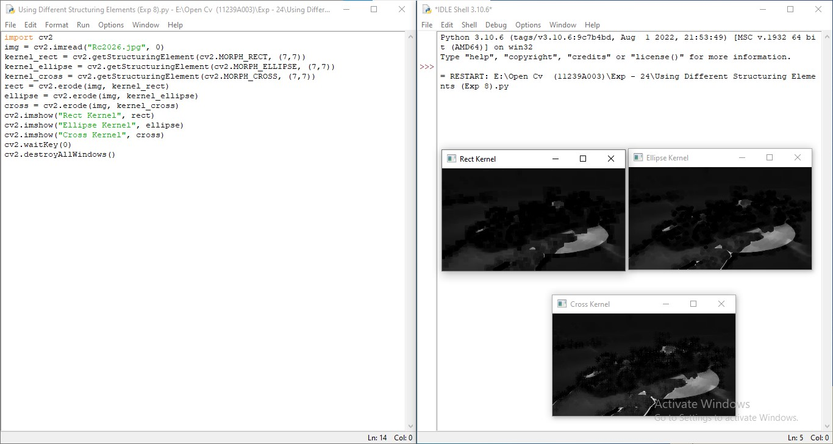
Ex. No.: 24 BASIC TEXT RECOGNITION FROM IMAGE (OCR USING TESSERACT)

Date: 30.03.2026

AIM:

To extract printed text from an image using Tesseract OCR and Python's pytesseract library.

PROCEDURE:

- Install the required libraries: pip install pytesseract and pip install Pillow.
- Install the Tesseract OCR engine on the system (available at https://github.com/tesseract-ocr/tesseract).
- Import cv2 and pytesseract.
- Load the image containing text using cv2.imread().
- Convert the image to grayscale to improve recognition accuracy.
- Use pytesseract.image_to_string(gray) to extract the text and print the result.

CODE:

import cv2
import pytesseract

# On Windows, set the Tesseract path:
# pytesseract.pytesseract.tesseract_cmd = r'C:\Program Files\Tesseract-OCR\tesseract.exe'

img = cv2.imread('text_image.jpg')
gray = cv2.cvtColor(img, cv2.COLOR_BGR2GRAY)

text = pytesseract.image_to_string(gray)

print("Extracted Text:")
print(text)

RESULT:

Text was successfully extracted from the image using Tesseract OCR via the pytesseract library.

Output :

